State of New Mexico CBP Programs

Community Survey State-Level Findings Sheet- 2017
All Modules

Prevention Goals and Objectives (only those referencing the NMCS)
Goal 1: Reduce underage drinking in New Mexico.
Objective 1: Reduce social access to alcohol by minors by… (increasing perception of risk of being caught; increased law enforcement efforts)
Objective 2: Reduce retail access to alcohol by minors by… (increasing perception of risk of being caught; increasing SID checks of retailers and increasing retail education, server training, etc.)

Goal 2: Reduce binge drinking among youth and adults in New Mexico.

Goal 3: Reduce drinking and driving among youth and adults in New Mexico.

Goal 4: Reduce prescription pain killer misuse and abuse among youth and adults in NM.

Brief Description of Community & Population:
New Mexico is a large, mostly rural state. Most of the population of the state lives in six relatively urban areas including Albuquerque, Las Cruces, Rio Rancho, Santa Fe, Roswell, and Farmington. There are 33 counties in NM. Five year estimates from the US Census’ American Community Survey indicate there were approximately one and half million residents of NM who are 18 and older living in the state. Of those, just under half (49.1%) were male. Of the entire population, 47.4% were Hispanic, 39.2% were non-Hispanic white, 8.5% Native American or Alaskan Native representing at least 22 different tribes, while just under 5% were African American/Black, Asian, or a combination of races. Approximately 26.4% have a high school degree, another 23.6% have some college education, 7.8% have an associate’s degree, 14.8% have a bachelor’s degree and 11.5% have a graduate or professional degree. Among 18 to 64 year olds, 19.8% live below the poverty line and among just 18 to 34 year olds, 25.4% live below the poverty line. Unemployment is around 9% but of those living below the poverty line, just over 40% are unemployed. Just over 26% of residents speak English less than “very well”.

Data Collection Method and Brief Sample Description in COMPARISON TO PREVIOUS YEARS’ SAMPLES

Data Collection Approach # 1: Time and Venue-Based Convenience Sampling
The first approach taken to collect data is the now routinized time and venue-based sampling within funded communities. This convenience sampling approach has been used by OSAP funded communities since 2008 and involves communities creating community-specific detailed data collection plans identifying the locations and times in the community where a representative sample of community residents can be asked to participate in the survey. Communities ideally replicate the protocol each year allowing for a comparable sample of adult residents to be surveyed each year and compared over the years. Depending on the size of the community, some are required by OSAP to collect data at local MVD offices as one of the locations. This is not always possible though in the smaller and more rural communities where there are few appropriate locations for collecting a representative sample of adults.

Community data collection protocols are reviewed by members of the State Epidemiological Outcomes Workgroup (SEOW) to ensure that communities are likely to capture a reasonably representative sample of adults based on their protocols. Local community providers and local evaluators are instructed in appropriate data collection methodology and how to maintain respondents’ confidentiality while completing the survey. This technique is frequently challenging for communities initially, but over time, many have come to regard it as imperative to improving the quality of the services they provide. Prevention communities are asked to track their data collection process in detail and submit a log of data collection activities with their end of year reports. The purpose of this is to compare what was originally proposed in the data collection protocol prior to data collection to what actually was done with respect to data collection. In particular, if communities found that some locations, originally expected to be good places to collect data, actually turned out to not be good locations or did not pan out for whatever reason, then this information would be recorded and be particularly useful to next year’s planning of the data collection process.

Over 7,492 surveys were collected using this methodology, which constitutes 69.8% of the aggregated sample. These data predominantly came from 21 of 33 counties where OSAP and/or DWI prevention funding is targeting prevention efforts. We are unfortunately unable to calculate a response rate using this methodology.

Data Collection Approach # 2: On-line survey via Social Media Ads
To supplement the convenience sample, another data collection approach used in FY17 was the implementation of an on-line version of the survey. Recruitment ads were placed on Facebook and Instagram targeting NM residents 18 and older. This methodology was piloted in FY14 among 18 to 25 year olds and then implemented in FY15 and FY16 for all adult residents 18 and older. This year, ads were run on both Facebook and Instagram. Facebook uses an algorithm to determine the optimal placement for ads based primarily on the number of hits the ads received on either social media platform. For this survey, most ads ended up running on Facebook as a result. Ads ran for a total of 9 weeks from February 26, 2017 to April 29, 2017. Six new ads were created using a story board approach, with multiple slides and text to entice respondents to take the survey. For the first time some of the ads featured photos or pictures of alcohol or pills in an attempt to reach a younger audience.

Over the 9 weeks the ads led to over 20,000 link clicks, with 307,179 people reached at the cost of approximately $0.25 per result and a result rate of 1.56%.

There were 12,257 total clicks on the link to go the survey. The click rate was 6.9%. When we consider unique clicks, which Facebook defines as 3 clicks from one person, there were 9,044. A total of 1,120 completed surveys for a response rate of 9.1% if we use total clicks as the denominator and a response rate of 12.4% if we consider the unique clicks as the denominator. Most ads were viewed on mobile news feeds (23%) or audience network (65%), few were viewed on desktop news feeds (3%) or desktop right columns (9%). Most website clicks resulted from the audience network (80%). A total of 668 surveys were collected by recruiting directly through the Facebook ads.

Daily and weekly incentives were offered to randomly selected individuals who completed the survey. After completing the survey, respondents were invited to enter to win an incentive, however, this was optional and not all respondents chose to do so. Each day, four $20 gas cards were given away to randomly selected respondents from that day. Each week, a randomly selected respondent was selected to receive two $20 gas cards from the week’s respondents for a total of 30 gas cards given out each week for 11 weeks. In reality, as the survey is slow to get started, we often do not have sufficient respondents in the first week or two to send out 30 gas cards. As momentum builds and word of the survey spreads, this is not an issue.

Data Collection Approach # 3: Time and Venue-Based Data collection using Qualtrics App and iPads

This year, the on-line survey was switched to a new on-line platform called Qualtrics. Qualtrics has some advantages over the previous platform because it allows for the survey to be attached to a QR code so that people can directly scan the QR code with their smart phones and take the survey without needing to see the Facebook ad. In addition, there is a Qualtrics app that allows one to collect survey responses while off line and upload the data later. Several programs experimented with this approach. Only one community used this as the sole approach; most combined it with traditional paper and pencil data collection. This approach was identical to the time and venue-based sampling approach, only data were collected on a tablet or iPad via the app rather than using a paper survey. A total of 788 surveys were collected via the Qualtrics app on an iPad or tablet or 7.3% of the overall total sample. This strategy appealed mostly to young people and was best implemented on college campuses.

Some communities used the QR code in heavily trafficked areas to allow people to take the survey later at their leisure. And finally, some communities sent email invitations directly to the on-line survey, circumventing the Facebook approach. An additional 2452 surveys were collected directly via email invitations, QR codes, or friends and family members telling others about the on-line survey.

A total of 3,249 surveys were collected using the on-line survey via iPads, the on-line link or QR codes.

Total Combined Sample

In FY17 a total of 10,741 completed questionnaires were collected compared with 12,634 in FY16, 9875 in FY15, and 6,793 in FY14. All 33 counties were represented in the data although five counties had very few completed questionnaires representing them.

Analysis Approach
Prior to conducting the analyses, we weighted the data to match NM Census 2015 data with regard to the distributions of gender, age, and race/ethnicity across the state so that our estimates more closely reflect a representative state sample. While this is ultimately a convenience sample, the intent behind weighting the overall sample is to reduce the overall influence of subpopulations that are typically over represented in our sample, specifically, young adults, Native Americans, and women. In particular, the over-representation of young adults would tend to increase our state-level substance use estimates unfairly.

PLEASE NOTE: In this report, all N’s (n’s) provided are unweighted but the percentages are weighted to reflect the population of NM with respect to age, race/ethnicity and gender.

Please note when interpreting these findings that tables do not always contain the actual wording of the question. Please refer to the survey itself for precise language.

- Demographic Characteristics
Descriptive statistics are provided for age, gender, race/ethnicity, education, New Mexico residency, military service and sexual orientation.

Table 1.1 Demographic characteristics of community2
Number of eligible respondents | N= 10,741
Characteristics | Weighted %
Age
18-20 | 5.4
21-25 | 9.3
26-30 | 8.9
31-40 | 16.3
41-50 | 14.8
51-60 | 17.2
61-70 | 15.1
71 or older | 12.7
Gender
Male | 49.1
Female | 50.9
Race/Ethnicity
White | 41.9
Hispanic | 44.9
Native American | 8.2
Other | 5.0
Education level¹
Less than high school | 6.3
High school or GED | 22.2
Some college | 21.9
College or above | 31.5
Currently an undergraduate | 18.1
New Mexico Residency
Less than 1 year | 4.2
1-5 years | 10.9
More than 5 years | 84.9
Number of Spanish Paper Surveys | 704
¹ Education levels are mutually exclusive.
2 Percentages are weighted, sample numbers are un-weighted,

Table 1.2 Demographic characteristics of community
Number of eligible respondents | N= 10,741
Characteristics | %
Active Duty in the Military Service or Veteran | 7.6
Identify as LGBT | 6.5
Parent/Caretaker of Someone under 21 living in the household | 34.9
Past 30-day housing stable | 94.9

- Alcohol Outcomes and Intervening Variables
Distributions of each response category are provided below for the alcohol-related intervening variables and outcomes. Percentages of dichotomized outcomes by age groups are provided as well.

Table 2.1. Means, ranges and percentages of alcohol use outcomes overall and by sex.
Outcomes |  | Overall |  | Men | Women
Outcomes | % of Yes | Mean (SD) | Range | % of Yes | % of Yes
# of drinks a week (n=10,741) | NA | …2.2 (0.09) drinks | 0-210 | NA | NA
Heavy drinkersª (n=10,399) | 4.0 | NA | NA | 4.4 | 3.8
Past 30-day alcohol use (n=10,418) | 47.6 | NA | NA | 52.5 | 43.2
Past 30-day binge drinking
All respondents (n=10,450) | 16.3 | 0.8 (0.04) times | 0-60 | 20.2 | 12.5
Current users^{b} only (n=4,880) | 34.7 | 1.8 (0.08) times | 0-60 | 39.1 | 29.5
Past 30-day driven under influence
All respondents (n=10,472) | 3.5 | 0.2 (0.02) times | 0-67 | 4.3 | 2.6
Current users^{b} only (n=4,895) | 7.4 | 0.3 (0.03)  times | 0-67 | 8.4 | 6.2
Past 30-day driven after binge drinking
All respondents (n=10,474) | 2.8 | NA | NA | 3.7 | 1.6
Current users^{b} only (n=4,900) | 5.7 | NA | NA | 7.1 | 3.8
ª Heavy drinkers are defined as more than 7 drinks in a week for women (approximately 1 drink a day) and more than 14 a week for men (approximately 2 drinks a day).
^{b} Current users: anyone who has had alcoholic drink in the past 30 days.

Table 2.2 Percentages of alcohol use outcomes by age groups among all respondents.
Age Range | Past 30-day alcohol use % |  | Past 30-day binge drinking % | Past 30-day driven under influence % | Past 30-day driven after binge drinking %
18-25 | 54.1 |  | 25.7 | 6.9 | 6.0
18-20 | 39.7 |  | 18.1 | 4.4 | 4.3
21-25 | 62.6 |  | 30.3 | 8.4 | 6.9
26-30 | 57.2 |  | 26.1 | 6.5 | 4.4
31-40 | 54.2 |  | 22.1 | 4.0 | 3.0
41-50 | 48.6 |  | 16.4 | 2.7 | 3.1
51-60 | 44.4 |  | 13.0 | 2.1 | 1.7
61-70 | 41.8 | 7.9 |  | 2.0 | 0.9
71+ | 34.5 | 5.0 |  | 1.3 | 0.7

Table 2.3 Perceptions of risk/legal consequences of alcohol consumption (Total Sample).
 | %
Perception of risk/legal consequences | Very likely | Somewhat likely | Not very likely | Not at all likely | Don't know
Likelihood of police breaking up parties where teens are drinking | 18.5 | 31.7 | 19.9 | 7.2 | 22.7
Likelihood of police arresting an adult for giving alcohol to someone under 21 | 26.2 | 27.1 | 16.9 | 7.1 | 22.6
Likelihood of someone being arrested if caught selling alcohol to a drunk or intoxicated person | 22.7 | 28.1 | 22.7 | 8.5 | 18.1
Likelihood of being stopped by police if driving after drinking too much | 30.8 | 36.0 | 16.8 | 4.9 | 11.5
Likelihood of being convicted if stopped and charged with DWI | 45.1 | 25.6 | 9.1 | 4.7 | 15.5
Access to alcohol | Very easy | Somewhat easy | Somewhat difficult | Very difficult | Don't know
Ease of access to alcohol by teens in the community | 44.0 | 31.3 | 7.5 | 2.7 | 14.5
Ease of access to alcohol by teens in the community from stores and restaurants | 10.6 | 20.9 | 29.4 | 18.7 | 20.3
Social Access | Total | Men | Women
Provided alcohol for minors past year | 3.9 | 4.6 | 3.1

Table 2.4 Percentages of perceived risk/legal consequences of alcohol consumption by age groups.
Access to Alcohol | Age groups (%)
Access to Alcohol | 18-20 | 21-25 | 18-25 | 26-30 | 31-40 | 41-50 | 51-60 | 61-70 | 71 +
Very or somewhat difficult for teens to access alcohol in the community | 15.0 | 11.1 | 12.6 | 13.0 | 12.8 | 13.0 | 12.2 | 9.6 | 10.2
Very or somewhat difficult for teens to access alcohol from stores and restaurants | 64.2 | 68.6 | 67.0 | 64.4 | 65.4 | 59.5 | 58.2 | 56.4 | 50.3
Purchasing and/or sharing of alcohol with a minor over past year (Yes) | 5.9 | 12.0 | 9.8 | 3.9 | 3.2 | 4.3 | 2.7 | 1.1 | 2.4
Permissive Attitudes to providing alcohol to minors | 18-20 | 21-25 | 18-25 | 26-30 | 31-40 | 41-50 | 51-60 | 61-70 | 71 +
Never okay to provide alcohol to minors | 40.0 | 50.1 | 46.4 | 64.8 | 69.6 | 70.3 | 70.8 | 70.5 | 71.2
Perception of risk/legal consequences (alcohol) | 18-20 | 21-25 | 18-25 | 26-30 | 31-40 | 41-50 | 51-60 | 61-70 | 71 +
Very or somewhat likely for police to break up parties where teens are drinking | 65.8 | 63.7 | 65.5 | 64.4 | 64.7 | 66.8 | 63.6 | 63.7 | 68.0
Very or somewhat likely for police to arrest an adult for giving alcohol to someone under 21 | 65.3 | 65.6 | 65.5 | 69.4 | 71.5 | 70.1 | 68.3 | 68.3 | 69.9
Very or somewhat likely for someone being arrested if caught selling alcohol to a drunk or intoxicated person | 66.8 | 61.8 | 63.6 | 60.4 | 61.4 | 60.2 | 61.8 | 61.3 | 65.5
Very or somewhat likely being stopped by police if driving after drinking too much | 79.4 | 78.2 | 78.7 | 77.2 | 75.8 | 75.2 | 74.6 | 74.6 | 72.7
Very or somewhat likely being convicted if stopped and charged with DWI | 89.6 | 87.8 | 88.5 | 84.5 | 86.2 | 81.6 | 83.0 | 80.4 | 81.4

Figure 2.1. Sources of obtaining alcohol for respondents 18-20 years old who reported drinking alcohol in the past 30 days. (n=665)
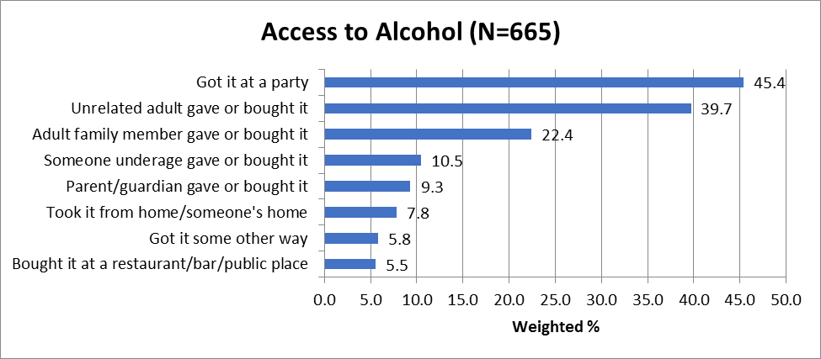

Figure 2.2. Opinions of providing alcohol to minors. (n=10,741)
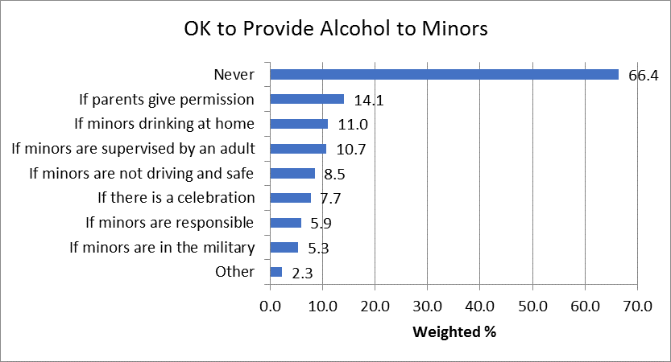
- Prescription Painkiller Outcomes and Intervening Variables

Distributions of each response category are provided below for the prescription painkiller-related intervening variables and outcomes. Percentages of dichotomized outcomes by age groups are provided as well.

Table 3.1. Means and percentages of prescription drug use outcomes overall and by sex.
 | %
Outcomes | Overall |  | Men | Women
Outcomes | % of Yes | Mean (SD) | % of Yes | % of Yes
Prevalence of receiving Rx painkiller past year (n=10,367) | 28.0 | NA | 25.8 | 30.2
Past 30-day Rx painkiller use for any reason (n=10,199) | 13.5 | …9.0 (0.37) days (current usersª only) | 13.6 | 13.2
Past 30-day painkiller use to get high
All respondents (n=10,250) | 3.1 |  | 3.1 | 2.7
Current users* only (n=1,301) | 22.1 |  | 23.2 | 19.6
Note. Ns are for overall estimates only.
*Current users: anyone who has used Rx painkillers in the past 30 days.

Table 3.2 Access to naloxone among those prescribed painkillers in the previous year
Outcomes | % of No | % of Yes | Don’t Know
When having been prescribed painkillers last year…
Were prescribed naloxone as well (n=2,753) | 87.3 | 4.3 | 8.4
Healthcare provider/pharmacy staff  talked about risks in using Rx painkillers  (n=2,565) | 31.1 | 68.9 | NA
Healthcare provider/pharmacy staff  talked about storing them safely (n=2,466) | 49.9 | 50.1 | NA
Have access to naloxone when having used painkillers to get high in the past 30 days (n=334) | 79.4 | 20.6 | NA

Table 3.3. Percentages of prescription drug use outcomes by age groups among all respondents.
Ages | Prevalence of receiving Rx painkiller past year | Past 30-day Rx painkiller use for any reason | Past 30-day Rx painkiller use to get high
18-25 | 21.3 | 11.5 | 4.2
26-30 | 22.7 | 10.9 | 2.9
31-40 | 25.3 | 11.9 | 3.3
41-50 | 28.6 | 14.6 | 2.8
51-60 | 32.6 | 15.4 | 3.1
61-70 | 32.3 | 15.7 | 2.3
71 + | 31.1 | 13.7 | 2.7

Table 3.4 Estimates for prescription painkiller intervening variables (Total Sample).
Risk of Harm | %
Risk of Harm | No risk | Slight risk | Moderate Risk | Great risk
Perceived risk of harm with misusing Rx painkillers | 5.2 | 10.7 | 25.6 | 58.5
Social Access | Yes | No
Giving or sharing Rx painkillers in past year | 5.9 | 94.1
Rx painkillers stored in locked box or cabinet* | 41.7 | 58.3
*We exclude respondents who indicate they have no prescription painkillers from this estimate.

Table 3.5. Estimates (percentages) for prescription painkiller intervening variables by age groups.
Risk of Harm | Age Range
Risk of Harm | 18-25 | 26-30 | 31-40 | 41-50 | 51-60 | 61-70 | 71 +
Perceived moderate or great risk of harm with misusing Rx painkillers (n=10,098) | 78.0 | 78.9 | 82.0 | 83.5 | 86.9 | 88.8 | 89.5
Social Access | 18-25 | 26-30 | 31-40 | 41-50 | 51-60 | 61-70 | 71 +
Giving or sharing Rx painkillers in past year (n=10,070) | 8.4 | 7.7 | 7.0 | 6.3 | 5.3 | 2.8 | 4.5
Rx painkillers stored in locked box or cabinet* (n=4,904) | 41.2 | 42.4 | 44.1 | 45.3 | 38.1 | 41.1 | 40.1
*Excluding respondents who indicate they have no prescription painkillers from this estimate.

Figure 3.1. Reasons for prescription painkillers use among current users. (n=1,316)
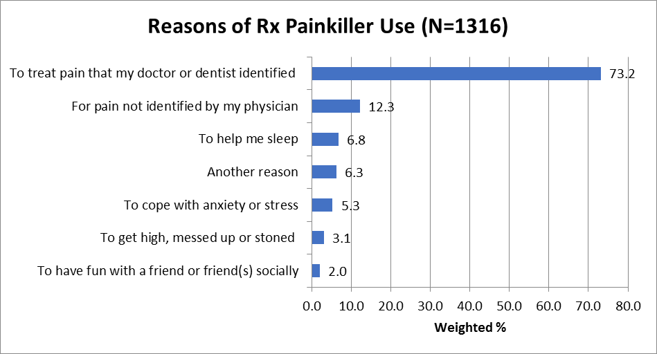

Figure 3.2. Sources of prescription painkillers among current users. (n=1,316)

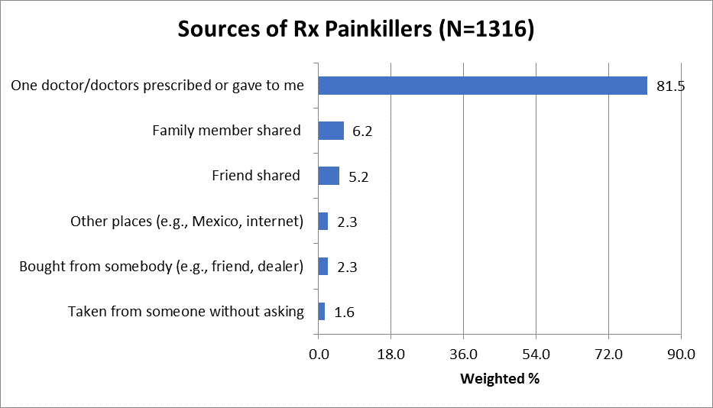

IV. Parental behaviors
Percentages are provided below for overall sample and by gender for access to ATOD via parents.

Table 4. Parents of minors residing in household reporting providing ATOD to a minor last year
Outcomes |  | %
Outcomes | Overall | Men | Women
Parents who reported it was NEVER OK to provide alcohol to a minor (n=3,750) | 72.6 | 68.3 | 76.3
Parents who reported providing alcohol to a minor (n=3,547) | 3.8 | 3.8 | 3.3
Parents who reported sharing Rx drugs (n=3,525) | 6.7 | 5.6 | 7.2
Parents who reported locking up Rx painkillers*(n=1,821) | 47.6 | 45.7 | 48.8
*Excluding respondents who indicate they have no prescription painkillers from this estimate.

V. Media Campaign

Table 5.1 Media campaign message recognition overall and by sex
Campaign Names | Overall n* |  | %
Campaign Names | Overall n* | Overall | Men | Women
Suck It Up! | 390 | 3.3 | 3.7 | 2.7
Good Drugs Gone Bad | 376 | 3.2 | 3.1 | 3.2
Parents Who Host Lose the Most | 552 | 5.1 | 4.6 | 5.6
A Dose of R_{x}eality | 748 | 5.9 | 5.6 | 6.1
Up and Away and Out of Sight | 220 | 1.8 | 1.7 | 1.8
Wake Up Now | 388 | 3.1 | 3.4 | 2.6
Never heard of any of these | 8003 | 74.7 | 74.3 | 75.9
*Reflects the number of people who recognized each campaign messages. Respondents were allowed to check more than one option.

Table 5.2. Interpretation of media campaign message overall and by sex
Campaign Message (N=9147) |  | %
Campaign Message (N=9147) | Overall | Men | Women
Stay in school if you want to be successful. | 12.7 | 14.4 | 11.0
Rx drugs can be dangerous if not used as intended. | 65.3 | 61.6 | 69.1
Reality is harsh, but medication can help. | 4.1 | 4.5 | 3.5
Daily exercise is good for your health. | 4.2 | 4.9 | 3.4
Take your medication as directed by your doctor. | 10.7 | 11.2 | 10.2
Vaccinate your kids. | 3.1 | 3.4 | 2.7

Optional Modules

- Community Module

This module was designed to assess the local community’s awareness and readiness to address alcohol problems in the community. These include addressing the prevention of underage drinking, heavy drinking, driving and driving, through efforts implemented by law enforcement or other avenues such as the creation of local ordinances or taxes that might offset the financial costs associated with problem alcohol use. A total of 17 communities included this module in their community survey efforts. Percentages are provided below for the consolidated response categories of all questions

Table 1. Distribution of responses in community module
Outcomes (N=5789) |  | %
Outcomes (N=5789) | Disagree | Agree | Neutral
Underage drinking is a problem in my community | 8.6 | 71.3 | 20.0
Support local law enforcement efforts to prevent underage drinking | 4.4 | 86.7 | 8.9
Heavy drinking is a problem in my community | 7.9 | 71.0 | 21.1
Support local efforts to prevent heavy drinking | 4.5 | 83.8 | 11.7
Drinking and driving is a problem in my community | 6.1 | 77.0 | 16.8
Support local law enforcement efforts to prevent drinking and driving | 3.5 | 89.9 | 6.6
I support the enforcement of laws prohibiting serving the intoxicated | 3.7 | 88.8 | 7.5
The overuse of alcohol harms the personal safety and well-being of community members | 3.9 | 87.0 | 9.2
Problems due to drinking hurts my community financially | 5.1 | 80.1 | 14.7
Past year experienced problems associated with alcohol misuse in my community | 23.1 | 51.3 | 25.5
Note. Disagree = strongly disagree + disagree; agree= strongly agree + agree; neutral= neither agree nor disagree.

II. College Community Module

This module was designed to assess the local college community’s awareness and readiness to address alcohol problems in the community. These include addressing the prevention of underage drinking, heavy drinking, and driving and driving, through efforts implemented by local law enforcement and campus police, or other avenues such as the creation of college policy, local ordinances or taxes that might offset the financial costs associated with problem alcohol use. A total of 7 college communities included this module in their community survey efforts. Percentages are provided below for consolidated response categories of all questions.

Table 2. Distribution of responses in college module
Outcomes (N=2376) |  | %
Outcomes (N=2376) | Disagree | Agree | Neutral
Underage drinking among college students is a problem in my community | 14.5 | 51.5 | 34.0
Binge drinking by college students is a problem in my community | 14.6 | 51.7 | 33.6
Drinking and driving by college students is a problem in my community | 14.5 | 50.9 | 34.6
My local college or university needs to do more to stop underage drinking and binge drinking among college students | 15.2 | 42.6 | 42.2
Local law enforcement needs to do more to stop underage drinking and binge drinking among college students | 14.6 | 52.1 | 33.4
College student drinking contributes to drinking among teens in my community. | 16.6 | 48.5 | 35.0
College drinking harms the personal safety and well-being of my community members | 16.4 | 52.1 | 31.5
Stores, bars and restaurants in my community do not do enough to discourage sales to intoxicated customers | 27.7 | 35.3 | 37.0
Stores, bars and restaurants in my community do not do enough to discourage sales to minors | 36.2 | 28.3 | 35.5
Problems due to drinking hurts my community financially | 14.3 | 55.8 | 29.9
Past year experienced problems associated with alcohol misuse in my community | 31.9 | 36.9 | 31.2
Note. Disagree = strongly disagree + disagree; agree= strongly agree + agree; neutral= neither agree nor disagree.

III. Tobacco Outcomes and Intervening Variables

Tobacco questions were previously included in the Core survey but were removed to a separate optional module this year. A total of 7 communities included the tobacco module in their community survey this year: 3 were college communities and 4 were non-college communities. Distributions of each response category are provided below for the tobacco-related outcomes.

Table 3. Percentages of cigarette/tobacco any use outcomes overall and by sex.
Tobacco Indicators (N=1783) |  | %
Tobacco Indicators (N=1783) | Overall | Men | Women
Cigarette: current use | 17.3 | 22.6 | 13.0
Chewing Tobacco: current use | 4.5 | 8.5 | 1.0
E- Cigarette: lifetime use | 22.1 | 26.2 | 18.4
E- Cigarette: past 30-day use* | 7.8 | 10.7 | 5.0
Purchased or provided tobacco to a minor in past year | 2.0 | 2.5 | 1.6
*Among all respondents who took the tobacco module.

- Mental Health

Mental health questions were previously included in the Core survey but were removed to a separate optional module this year. Three additional items were included this year to assess the extent to which health care providers are screening patients for mental health and substance abuse problems. A total of 14 communities included the mental health module in their community survey this year: 3 were college communities and 11 were non-college communities. Percentages are provided below for overall sample and by biological sex for the mental health outcomes of interest.

Table 4. Percentages of mental health outcomes overall and by sex
Outcomes (N=4780) |  | %
Outcomes (N=4780) | Overall | Men | Women
Met critical threshold for serious mental illness* | 8.7 | 8.0 | 9.3
Self-identified having mental health or drug/alcohol problems in the past year | 17.8 | 16.5 | 18.9
Suicidal thoughts in the past year | 4.9 | 5.4 | 4.3
Sought help on mental health or drug/alcohol problems in the past year | 14.7 | 13.7 | 15.8
Had difficulty accessing treatment for mental health or substance abuse problems | 5.1 | 5.0 | 5.1
Past year screened for alcohol or drug problems | 5.5 | 6.5 | 4.4
Past year screened for depression | 11.8 | 10.0 | 13.8
Past year screened for suicidal ideation | 3.6 | 3.6 | 3.6
*Serious mental illness is defined as having ≥ 13 points on the WHO screening scale.
Summary of 2017 Community Survey Findings

In FY17, over 10,000 NM residents participated in the NMCS. This was slightly down from FY16, when over 12,000 participated, however, overall, this was a very respectable sample. Five NM colleges participated in data collection as part of the PFS15 cohort, which increased our sample of young adults considerably. In the results presented in this report, data are weighted to reflect the general population estimates of New Mexico as a whole, which means that despite an over sample of young adults attending college, the estimates of alcohol and other substance use presented in this report are not unduly influenced by the over sampling.

When interpreting these results, it is important to keep in mind that these results reflect data from a convenience sample and not a true probability sample. Therefore, we need to keep in mind that those who complete a survey of this type may be different from those who do not. While every attempt is made to capture a sample that represents each community participating in the survey as accurately as possible, there is likely some bias reflected.

Compared to 2016, our overall estimates of drinking, including past 30-day drinking, past 30-day binge drinking, past 30-day driving under the influence, and past 30-day driving after binge drinking are virtually identical. There were very slight increases in FY17 in respondents feeling it was very likely that police would break up parties were teens were drinking, arrest adults providing alcohol to minors, and arrest someone selling alcohol to an intoxicated patron. On the other hand, fewer respondents felt it was very likely someone would be stopped by police if driving after drinking too much (42.6% in FY16 vs. 30.8% in FY17). On the other hand, for some reason, far more respondents in FY17 (45.1%) compared to FY16 (16.7%) felt it was very likely someone would be convicted if stopped and charged with a DWI. More respondents also felt it was very easy for teens to access alcohol in FY17 (44.0%) than in FY16 (37.5%). Only slightly more respondents indicated providing alcohol to a minor in the past year (3.1% in FY16 vs. 3.9% in FY17). Of respondents 18 to 20 years old who reported drinking in the past 30 days, 45.4% indicated they got it at a party in FY17 versus 39.4% in FY16. However, an almost identical percentage in FY16 and FY17 indicated it was never okay to give alcohol to a minor (66.7% in FY16 vs. 66.4% in FY17).

The prevalence of receiving a prescription painkiller in the previous year was slightly lower in FY17 (28.0%) than in the FY16 (29.9%) as was past 30-day use of a prescription painkiller for any reason (15.6% in FY16 vs. 13.5% in FY17). In addition, past 30-day painkiller use to get high also decreased slightly in the entire sample and among current users (e.g., 25.0% among current users in FY16 vs. 22.1% among current users in FY17). This year, respondents were asked about naloxone access and whether prescribers were providing appropriate information about opioids when prescribing them. The results indicate that few respondents who received a prescription for opioids in the previous year were also prescribed naloxone, however, almost 69% indicated the healthcare provider or pharmacy staff discussed the risks in using Rx opioid painkillers. An additional surprise was that 50.1% indicated that the healthcare provider and/or pharmacists discussed safe storage of prescription opioids, which far exceeded our expectations. Finally, 20.6% indicated they had access to naloxone when having used painkillers to get high. The perceived risk of harm associated with misusing prescription opioids and the sharing of prescription opioids was virtually unchanged between FY16 and FY17, but respondents indicating they locked their prescription painkillers in a box or cabinet increased slightly from 38.2% in FY16 to 41.7% in FY17.

In comparing the behaviors of parents of minors in FY16 to FY17, the only meaningful difference is a slight increase in the percentage of parents who reported locking up their prescription painkillers, from 45.5% in FY16 to 47.6% in FY17. While only a slight increase, it does suggest that perhaps parents are aware of the dangers involved in opioid use and the chance for misuse among youth. Unfortunately, the overall percentage is still relatively low given the huge increase of media coverage devoted to the dangers and risks associated with opioid use.

Overall awareness of both A Dose of R_{x}eality and Parents Who Host Lose the Most campaigns decreased between FY16 and FY17 from approximately 8% in FY16 for both campaigns to 5-6% in FY17 for both campaigns. Fortunately, more people recognized the correct meaning for the A Dose of R_{x}eality campaigns in FY17 (65.3%) than in FY16 (57.9%). With the very visible increase in the A Dose of R_{x}eality presence beginning last this spring and summer in NM, we anticipate a considerable increase in overall recognition of the campaign in FY18. With respect to Parents Who Host Lose the Most, these campaigns are very community specific and therefore, a state-wide estimate of recognition is not an accurate measure. Awareness of this media campaign should be assessed at the community-level for a more accurate assessment of reach.

Overall, we feel very pleased that our estimates came in so closely to those from FY16, with only slight increases and decreases. Since the PFS 15, PDO and SPF Rx have with not yet started or only just started implementation of prevention strategies, it makes sense that we might not see large decreases yet in many of the outcome or intervening variable indicators at the state-level between FY16 and FY17, but we might anticipate improvements over the next several years. Communities are continuing to improve their data collection capacity and the quality of data are improving each year as a result, providing an increasing sense of the reliability of these findings over time.

SUMMARY OF NON-CORE MODULES

In FY17, tobacco and mental health indicators were removed from the Core module and moved to elective modules. Therefore, not all communities elected to include these modules. However, when we compared the smaller FY17 samples with much larger FY16 samples, estimates were not all that different. In FY16, 22.2% reported being current cigarette smokers compared with 17.3% in FY17, lifetime use of E-cigarettes increased only about 1 percentage point between FY16 (21.2%) and FY17 (22.1%) and past 30-day E-cigarette use decreased slightly from 8.6% in FY16 to 7.8% in FY17. Also decreasing was the percent of respondents who purchased or provided tobacco to minors.

A slightly greater percentage of respondents in FY17 (8.7%) met the critical threshold for serious mental illness than in FY16 (7.5%), but those self-identifying as having a mental health or substance use problem in the past year remained almost identical (17.6% in FY16 vs. 17.8% in FY17). Those reporting suicidal thoughts in the previous year decreased slightly in FY17 (4.9%) from FY16 (5.4%) and the percent reporting seeking help in the past year for a mental health or substance use problem increased slightly (14.7% in FY17 vs. 13.9% in FY16). In FY17, for the first time, we also asked respondents whether they were screened for mental health, alcohol, or drug problems, or suicidal ideation by a health care provider in the past year. Few respondents indicated being screened for alcohol or drug problems (5.5%) but twice as many indicated they were screened for depression (11.8%). Finally, only 3.6% indicated being screened for suicidal ideation.

Two new non-core modules were added in FY17, one targeting community awareness and readiness to address alcohol issues and the other targeting specifically college communities and feelings about what the college and local community can and should do to address underage and problem drinking.

The general community module was completed by almost 6,000 respondents. Most respondents agreed that underage drinking, heavy drinking, and drinking and driving were problems in the community and even more supporting law enforcement efforts to address the problems. Just over 50% indicated experiencing problems associated with alcohol misuse in the community, just over 80% indicated that problem drinking hurt the community financially, and 87% felt that the overuse of alcohol harmed the personal safety and well-being of community members. These findings should be used to encourage local law enforcement to engage in preventative and even enforcement activities in their communities.

In the college community module far fewer respondents felt there were problems with alcohol in the community, however, it should be noted that this sample does reflect primarily students and even then around half of the sample felt there were problems and supported law enforcement efforts to prevent and deter problem drinking. Indeed, 52.1% felt that college drinking harms the personal safety and well-being of community members and 55.8% felt that problems due to drinking hurt the community financially. A significant proportion of respondents neither agreed nor disagreed with the statements in the module. Despite only about a 50% agreement with the statements in this module, it does suggest that about half of all students and those living in college communities feel that college drinking is a problem and a concern. While not an overwhelming level of support, it does suggest that even students who drink recognize the costs and problems associated with underage and binge drinking by college students. These results should be shared with college administrators, campus police, and local law enforcement to encourage greater action on their part to prevent and reduce alcohol consumption on and near college campuses.

